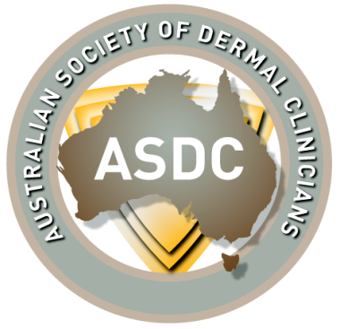
Australian Society of
Dermal Clinicians
Purpose:

This guideline outlines the role and duties of the Marketing and Media position with the ASDC. The guideline and protocols outline the breakdown of duties/tasks performed by the member/s and a standardized policy for how tasks are handled. The main aim is to increase our brand and awareness amongst consumers.

Marketing and Media Role

The Marketing and Media member/s is responsible for handling the following:
- Increase brand awareness

- Curate, publish and manage content across blogs, websites and social media
- Marketing: Lead our marketing, communications and design activities. Deliver innovative campaigns to promote the society, develop brand identity and profile, as well promote events hosted by the society such as webinars, conferences, workshops, open days, etc.

- Media: Keeping all forms of media including website, facebook, up to date.
- Membership: Drives the social media promotion for membership renewal.

- Works closely with all other committee members particularly Education Officer to promote events.
Marketing and Media Protocol
To ensure professionalism and standardization within the process of managing the marketing and media within the society, anyone in the role of Marketing and Media must be informed and follow the protocol outlined below.
Marketing and Media Protocol
- Promotion: All upcoming events including webinars, annual conference and membership renewal as well as advertising job positions need to be promoted.
  - Liaise with other committee members to understand requirements of event to be promoted
  - Post needs to be uniform across all platforms ie. Website, facebook etc.
  - How to update Website- log onto Wix.com. Click on ‘edit site’ button. Using dropdown menu on top of screen chose the page you want to edit. Once on that page, click to edit. Once finished click ‘save’ then ‘publish’ once you are ready for the changes to go live.
  - How to update and post on facebook- log onto facebook. You will be given access and made an Administrator on the ASDC’s facebook page as well as their closed group.
  - Access to shuttershock? photos

